# BREAST CANCER CLASSIFICATION USING TEMPERATURE DISTRIBUTION ON THE SURFACE BY DEEP LEARNING MODELS

# Report

Submitted in partial fulfilment of the requirements for the degree of

**BACHELOR OF TECHNOLOGY**

in

**MECHANICAL ENGINEERING**

by

**Anuj Mittal(171ME210)**

**Prajwal Pohekar(171ME153)**

**Vishruth Shandilya(171ME279)**

Under the guidance of

**Prof. Vijay Desai**

**&**

**Dr. N. Gnanasekaran**



**DEPARTMENT OF MECHANICAL ENGINEERING**

**NATIONAL INSTITUTE OF TECHNOLOGY KARNATAKA**

**SURATHKAL, MANGALORE-575025**

**NOVEMBER, 2020**

**DECLARATION**

*By the B.Tech students*

We hereby *declare* that the Project Work Report entitled “**Breast Cancer Classification Using Temperature Distribution on the Surface by Deep Learning Models**” which is being submitted to the **National Institute of Technology Karnataka, Surathkal** for the award of the Degree of **Bachelor of Technology** in **Mechanical Engineering** is a *bonafide report of the work carried out by me*. The material contained in this Project Work Report has not been submitted to any University or Institution for the award of any degree.

*Register Number, Name & Signature of the Student:*

1. **171ME210, Anuj Mittal**
2. **171ME153. Prajwal Pohekar**
3. **171ME279, Vishruth Shandilya**

Department of Mechanical Engineering

Place: NITK, SURATHKAL

Date: November 7 2020

**CERTIFICATE**

This is to *certify* that the B.Tech. Project Work Report entitled “**Breast Cancer Classification Using Temperature Distribution on the Surface by Deep Learning Models**” submitted by:

*Sl.No. Register Number & Name of Student*

1. **171ME210, Anuj Mittal**
2. **171ME153. Prajwal Pohekar**
3. **171ME279, Vishruth Shandilya**

as the record of the work carried out by him/her/them, is *accepted as the B.Tech*. *Project Work Report submission* in partial fulfilment of the requirements for the award of degree of **Bachelor of Technology** in **Mechanical Engineering**.

|  |  |
| --- | --- |
| Project Guide  Prof. Vijay Desai  Professor  Department of Mechanical Engineering  NITK, Surathkal | Project Guide  Dr. N. Gnanasekaran  Assistant Professor  Department of Mechanical Engineering  NITK, Surathkal |

Chairman – DUGC

Dr. **Shivananda Nayaka**

Associate Professor

Department of Mechanical Engineering

NITK, Surathkal

**ACKNOWLEDGEMENT**

This report is an outcome of the Major Project we have partially completed in the VII semester of our course in Bachelor of Technology at National Institute of Technology, Karnataka.

We would like to take this opportunity to express my sincere gratitude to all those who have helped us throughout this project. It gives us immense pleasure to acknowledge all those who have rendered encouragement and the support for the successful completion of our work.

First of all, we would like to thank the Head of Department, **Prof. Shrikantha S Rao** and the DUGC Chairman, **Dr. Shivananda Nayaka,** for providing all the required resources for the successful completion of the project.

We place our sincere thanks to project guide P**rof. Vijay Desai**, Professor, Department of Mechanical Engineering, NITK and **Dr N. Gnanasekaran**, Assistant professor, Department of Mechanical Engineering, NITK for guiding us throughout my project. We would like to thank them for their excellent guidance, patience, and sound criticism which were essential in the fulfilment of this project work.

Finally, we would like to thank all teaching and non-teaching faculty members of NITK for their extensive support.

We hope that we can build upon the experience and knowledge that we have gained and make a valuable contribution to society in the coming future.

**CONTENTS**

**Title**

**Declaration**………………………………………………………………….. i

**Certificate**…………………………………………………………………… ii

**Acknowledgement**………………………………………………………….. iii

**Abstract**…………………………………………………………………….. iv

**Nomenclature**………………………………………………………………. a

**List of Figures**……………………………………………………………… b

**Chapters**

**Introduction**…………………………………………………………. 1

**Numerical Model**……………………………………………………. 4

**Results and Discussion**…………………………………………….. 6

**Conclusions**………………………………………………………….. 11

**Future Scope**………………………………………………………… 12

**References**…………………………………………………………… 13

**Appendix-A**………………………………………………………………… 14

**ABSTRACT**

Although the Breast Cancer Tumor training dataset set is available today [5], it is insignificant, and training on a smaller dataset may result in overfitting of a model, which may not have high accuracy. In this work, we are trying to create a larger dataset that can be used to build a high-accuracy machine learning model to predict whether the sample is a breast cancer tumor or not. Using Pennes bioheat equation, which is used to estimate the size and location of a tumor in the breast, samples are generated with varying sizes and locations of tumors in the breast. Hence, we can apply this model in an early diagnosis identification of symptomatic cancer cases at the earliest possible stage and reduce fatalities. To accomplish this, a three dimensional Pennes bioheat equation is simplified to a two dimensional equation and along with the boundary conditions, the required temperature distribution is obtained. An in-house matlab code has been developed to solve the numerical model and more data set is created using Artificial Neural Network.

**NOMENCLATURE**

cp specific heat of the tissue, J/kg ⋅ K

cpb specific heat of the blood, J/kg ⋅ K

k thermal conductivity,W/m ⋅ K

L length, cm

Qm metabolic heat generation,W/m3

Qs distributed volumetric heat source due to spatial heating,W/m3

r radius, cm

t time, s

T temperature, °C

Ta temperature of the artery, °C

V volume of the cell, m3

Y distance of the center of tumor from bottom boundary of the tissue domain, cm

Greek symbols

$η_{b}$ blood perfusion rate, m3 /s ⋅ m3

ρ density, kg/ m3

ρb density of blood, kg/ m3

**LIST OF FIGURES**

Figure-1 2D representation of breast

Figure-2 Grid Used in FDM Model

Figure-3 Temperature distribution along top boundary

Figure-4 Temperature distribution along centerline

# CHAPTERS

# INTRODUCTION

Time has shown Mankind many fatal diseases, and we have also succeeded in finding treatment for most of these diseases. But one of these diseases known as Cancer continues to grow globally, exerting tremendous physical, emotional and financial strain on individuals, families, communities, and health systems. Cancer is the second leading cause of death globally, accounting for an estimated 9.6 million deaths, or one in six deaths, in 2018. Many health systems in low- and middle-income countries are least prepared to manage this burden, and large numbers of cancer patients globally do not have access to timely quality diagnosis and treatment.

Breast cancer is the most frequent cancer among women, impacting 2.1 million women each year, and also causes the greatest number of cancer-related deaths among women. In 2018, it is estimated that 627,000 women died from breast cancer – that is approximately 15% of all cancer deaths among women. Much research has shown the Breast cancer risk in males as well [1]. Cells in the body normally divide (reproduce) only when new cells are needed. Sometimes, cells in a part of the body grow and divide out of control, which creates a mass of tissue called a tumor. If the cells that are growing out of control are normal, the tumor is called benign (not cancerous). If, however, the cells that are growing out of control are abnormal and do not function like the body's normal cells, the tumor is called malignant (cancerous).

#### **Two distinct strategies promote early detection:**

1. An early diagnosis identifies symptomatic cancer cases at the earliest possible stage.
2. Screening aims to identify individuals with abnormalities suggestive of specific cancer or pre-cancer who have not developed any symptoms and refer them promptly for diagnosis and treatment.

With innovation in computation devices and the ability to perform complex calculations, we can manipulate the fact that the human body generates and conducts heat in various ways. The human body is nothing but a thermal system. Pennes Bioheat equation governs the transport of heat in the blood perfused tissue. Thermal and optical signatures changes with the change in conditions of the tissue. The growth of a tumor in a body increases the rate of metabolism and changes the blood perfusion rate in the region of its appearance. Due to the changed behavior, a variation in the thermal and optical signals of the tissue is observed. Cancerous tissue has different temperature profiles and different temporal transmittance and reflectance signals than that of healthy tissue. Measurement and analysis of these signatures, open up a way to estimate the presence of any abnormality in the tissue that has caused it. Based on various signal data obtained through research it has become easier to apply various mathematical models and heat equations to locate and/or treatment of tumors. Pennes bioheat equation solved using finite difference method is one such application. The cancerous cells depending on location and size emit unique thermal signals, which are then sampled using MCMC techniques to find the location and size. The location and size is obtained by solving the inverse problem (i.e., starts with effect then calculation) given the flux, temperature and radiation intensities (thermal parameters) initially to find transient temperature, then using the transient temperature thermal parameters are obtained using Metropolis-Hastings algorithm [9].

ANN classifier using Back propagation algorithm(BPA) and RBF is used to train the neural network and classify the cancers as easy benign, difficult benign, easy cancer and difficult cancer[[10]](https://docs.google.com/document/d/19HzqSbQTrthv7iii_yYmsUPI87dgbDlwOOZMnpW1-OM/edit) .

Detection of breast cancer using the thermal detection method (thermography) is one of the most advanced and expeditious methods because of the adverse side effects witnessed in other treatment methods. Like in the case of Mammographic Screening a cohort of 100 000 women each receiving a dose of 3.7 mGy to both breasts and who were screened annually from age 40 to 55 years and biennially thereafter to age 74 years, it is predicted that there will be 86 cancers induced and 11 deaths due to radiation-induced breast cancer [3]. With the era of computation and digital boom, thermography methods like DITI (Digital infrared thermal imaging) are taking an edge over conventional treatment methods. In [6] prospective clinical trial, 92 patients for whom breast biopsy was recommended based on prior mammogram or ultrasound underwent DITI. Three scores were generated an overall risk score in the screening mode, a clinical score based on patient information, and a third assessment by an artificial neural network. Sixty of 94 biopsies were malignant, and 34 were benign. DITI identified 58 of 60 malignancies, with 97% sensitivity, 44% specificity, and 82% negative predictive value depending on the model used. Compared to an overall risk score of 0, a score of 3 or greater was significantly more likely to be associated with malignancy (30% vs 90%, *P* < .03).

**2. NUMERICAL MODEL**

#### **2.1 Thermal Properties**

The variation in the temperature distribution on the surface of a breast with tumour and a healthy breast is due the difference in the blood perfusion rate and metabolic heat generation rate of healthy and cancerous tissues. For this study, the normal body temperature, Ta, is taken to be 37 $°C$. The top surface of the breast is exposed to surrounding which is assumed to be at a temperature, Tf, of 20 $°C.$ The convective heat transfer coefficient between the top surface of breast and surrounding, h, is taken to be 20 $\frac{W}{{Km}^{2}}$ [2]. The thermo-physical properties of blood and tissues are: The densities of tissue and blood, $ρ=ρ_{b}=1052 \frac{kg}{m^{3}}$, the specific heats of tissue and blood, $C_{p}=C_{pb}=3800\frac{J}{kg.K}$ and thermal conductivity, $k = 0.5\frac{W}{m.K}$

The metabolic heat generation rate of a healthy breast tissue, Qm, is taken to be 400 $\frac{W}{m^{3}}$ [2]. The blood perfusion rate of a healthy breast tissue, $η_{b}$, is taken as 1 x 10-4 s-1.

#### **2.2 2-D Geometry**

The human breast is a 3D tissue structure. The tumor inside the breast is also a 3D structure. But, to simplify the calculations, the present study is done using a 2D representation of the human breast, which is shown in Fig 1. The justification for this conversion of the 3D breast into 2d rectangular geometry is well proven by Das et al. For validation, the results of Das et al. on a rectangular geometry of 10cm base and 5cm height are used. The tumor geometry used in this study is a 1cm x 1cm square-shaped representation of a 3D tumor. It is located at the center of the breast 2D geometry.

#### **2.3 Boundary Conditions**

The southern boundary of the rectangular representation of the breast is in direct and constant contact with the body. Thus, it is normally maintained at the core body temperature of Ta. The top surface or the northern boundary of the geometry is in direct contact with the surrounding. Thus, it participates in convective heat transfer with the surrounding which is at a temperature of Tf. Thermal conditions of the left (x = 0, y) and the right (x = 2L, y) boundaries of the tissue are not affected by the presence of the tumor and are thus adiabatic.

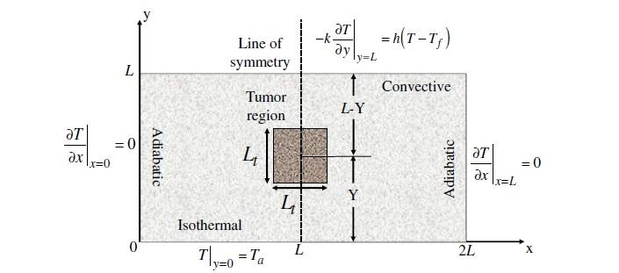

Figure 1. 2D representation of breast [2]

## RESULTS AND DISCUSSION

#### **3.1 Finite Difference Method Model**

#### The pennes heat transfer equation is:

${ρc}_{p}\frac{∂T}{∂t} = k\left(\frac{∂^{2}T}{∂x^{2}} + \frac{∂^{2}T}{∂y^{2}}\right)+ η_{b}ρ_{b}c_{pb}\left(T_{a} - T\right)+ Q_{m} + Q_{s}$…(i)

Where ρ, cp, and ηb are the density, specific heat, and blood perfusion rate of the tissue respectively, and ρb and cpb are the density and the specific heat of the blood, respectively. Qm and Qs represent the metabolic heat generation rate and distributed volumetric heat source due to spatial heating, respectively.

As the geometry in figure 1 is symmetric about the centerline (Ly), for the purpose of computation, consideration is given to the right hand part of it. Thus, the left hand boundary of the computational domain has a symmetric boundary condition i.e., adiabatic. The 5cm x 5cm geometry is divided into 50 x 50 grid, such that $∆x=0.25cm and ∆y=0.25cm.$ For a simplistic view of the FDM equations, two subscripts for the location of nodes are used as shown in figure 2.

FDM equations are obtained using energy conservation technique. For the work that has been completed till now, heat transfer due to perfusion of blood is not considered.

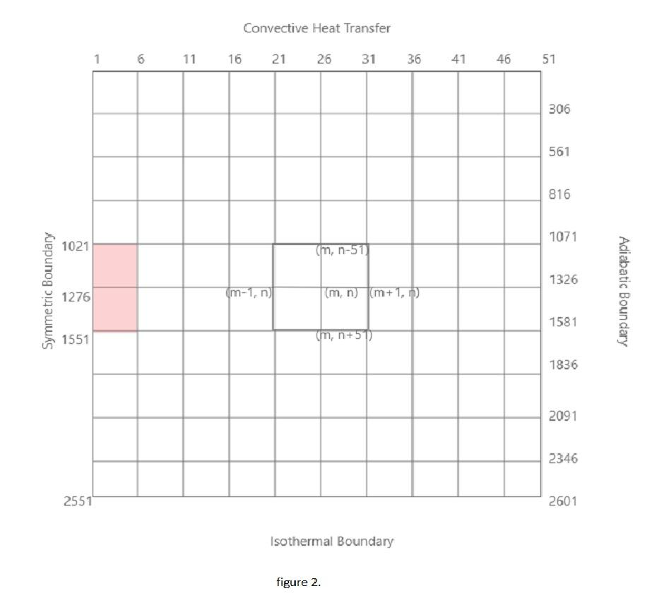

Figure 2. Grid used in FDM model

For nodes interior of normal tissue

$T_{m-1,n} + T_{m+1,n} +T_{m,n-1} +T_{m,n+1} - 4T_{m,n} = -q/k(∆x∆y)$ (3.1.1)

For nodes interior of tumorous tissue

$T_{m-1,n} + T_{m+1,n} +T_{m,n-1} +T_{m,n+1} - 4T_{m,n} = -{q_{t}}/k(∆x∆y)$ (3.1.2)

For nodes on northern boundary

$T_{m-1,n} + T_{m+1,n} + 2T_{m,n+1} - 2(h{∆x}/k + 2)T_{m,n} = -q/k(∆x∆y) - 2h{∆x}/kT_{∞}$ (3.1.3)

For nodes at southern boundary

$T_{m,n}= T_{a}$ (3.1.4)

For node 1

$T_{m+1,n} + T_{m,n+1} - (h{∆x}/k + 2)T_{m,n} = -q/k(\frac{∆x∆y}{2}) - h{∆x}/kT_{∞}$ (3.1.5)

For node 11

$T_{m-1,n} + T_{m,n+1} - (h{∆x}/k + 2)T_{m,n} = -q/k(\frac{∆x∆y}{2}) - h{∆x}/kT_{∞}$ (3.1.6)

For nodes on eastern boundary

$2T_{m-1,n} + T_{m,n+1}+ T_{m,n-1}- 4T_{m,n1} = -q/k(\frac{∆x∆y}{2})$ (3.1.7)

For nodes on western boundary, inside normal tissue (for example node 766)

$2T_{m+1,n} + T_{m,n+1}+ T_{m,n-1}- 4T_{m,n1} = -q/k(\frac{∆x∆y}{2})$ (3.1.8)

For nodes on western boundary, inside tumorous tissue (for example node 1276)

$2T_{m+1,n} + T_{m,n+1}+ T_{m,n-1}- 4T_{m,n1} = -{q_{t}}/k(\frac{∆x∆y}{2})$ (3.1.9)

For nodes at corner of tumorous tissue, at western boundary (nodes 1021 and 1551)

$2T_{m+1,n} + T_{m,n+1}+ T_{m,n-1}- 4T_{m,n1} = -\frac{q + q_{t}}{k}(\frac{∆x∆y}{4})$ (3.1.10)

For nodes at corner of tumorous tissue, interior of normal tissue (nodes 1026 and 1556)

$T_{m-1,n} + T_{m+1,n} + T_{m,n+1}+ T_{m,n-1}- 4T_{m,n1} = -q/k(\frac{3}{4}∆x∆y) - {q_{t}}/k(\frac{1}{4}∆x∆y)$ (3.1.11)

For nodes sharing equal areas between normal and tumorous tissue (for example node 1022, 1552)

$T_{m-1,n} + T_{m+1,n} + T_{m,n+1}+ T_{m,n-1}- 4T_{m,n1} = -\frac{q + q_{t}}{k}(\frac{∆x∆y}{2})$ (3.1.12)

Thus, for 2601 nodes, a set of 2601 equations is obtained. These equations are solved simultaneously using Matlab software. The Matlab code for the solution of these simultaneous equations can be found in Appendix-A.

The FDM model was used to solve the given problem for two cancerous tissues. The blood perfusion rate and metabolic heat generation rate for tumors I and II are: $η_{bt1}=1x{10}^{-3}s^{-1}$ and $Q_{mt1} = 4000 \frac{w}{m^{3}}$, $η_{bt2}=1x{10}^{-2}s^{-1}$ and $Q_{mt2} = 40000 \frac{w}{m^{3}}$

Figure 3 shows the temperature distribution obtained by the Matlab code at the top surface of the geometry. The variation in temperature due to tumor I and tumor II is distinguishable. Figure 4 shows the temperature distribution in y direction along the centerline. The validation of these results is remaining as effects of blood perfusion rate are not considered while solving the problem. In spite of that, the nature of the temperature distribution is similar to that obtained by Das et al[2]. The aim of the work is to obtain the surface temperatures and to identify the size and location of the tumor. With minimum set of data based on the simulations, large data set is generated in order to efficiently estimate the unknown parameters. From the figures, it should be noted that the temperature at the tumor location is higher than the near by skin surface. This is due to the high metabolism rate. Due to this, more heat is generated and it results as increase in temperature at the surface.

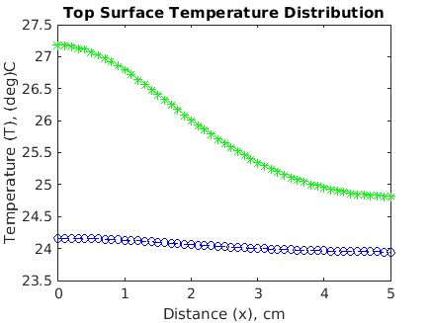

Figure 3. Temperature distribution along top boundary; Tumor I, Tumor II

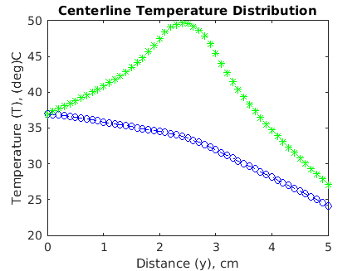

Figure 4. Temperature distribution along centerline; Tumor I, Tumor II

## CONCLUSION

In this study, the thermal effect of cancerous tissues was understood. A complex shape of a human breast was simplified to a 2D rectangular geometry. Using FDM and energy conservation method, the problem of temperature distribution was reduced to solving 2601 simultaneous equations. Using Matlab, these equations were solved for two cancerous tissues with different metabolic heat generation rates. The temperature distribution thus obtained was plotted for the top surface and centerline.

## FUTURE SCOPE

The effect of blood perfusion rate on the temperature distribution needs to be obtained. The results then need to be validated with existing literature. A large number of samples should be generated in order to train a deep learning model to detect the size and location of the tumor from the given temperature distributions. Then, various deep learning models should be compared for better accuracy. The best model(s) should be trained and then be used on real test samples.

**REFERENCES**

##### [David E. Anderson, Michael D. Badzioch, Breast Cancer Risks in Relatives of Male Breast Cancer Patients, JNCI: Journal of the National Cancer Institute, Volume 84, Issue 14, 15 July 1992, Pages 1114–1117](https://doi.org/10.1093/jnci/84.14.1114)

##### [Koushik Das, Subhash C. Mishra, Non-invasive estimation of size and location of a tumor in a human breast using a curve fitting technique 56 (2014) 63–70.](https://doi.org/10.1016/j.icheatmasstransfer.2014.04.015)

##### [Martin J. Yaffe, James G. Mainprize Risk of Radiation-induced Breast Cancer from Mammographic Screening. From the Imaging Research Program, Sunnybrook Health Sciences Centre, University of Toronto. Jan 1 2011.](https://doi.org/10.1148/radiol.10100655)

##### [Sam Shapiro; Philip Strax, MD; Louis Venet, MD Periodic Breast Cancer Screening in Reducing Mortality From Breast Cancer;215(11):1777-1785](https://jamanetwork.com/searchresults?author=Louis+Venet&q=Louis+Venet)

##### [F. A. Spanhol, L. S. Oliveira, C. Petitjean, and L. Heutte, "A Dataset for Breast Cancer Histopathological Image Classification," in IEEE Transactions on Biomedical Engineering, vol. 63, no. 7, pp. 1455-1462, July 2016.](https://ieeexplore.ieee.org/document/7312934)

##### [E.A. Sickles Effectiveness of a noninvasive digital infrared thermal imaging system in the detection of breast cancer Breast Diseases: A Year Book Quarterly, Volume 20, Issue 3, 2009, Pages 268-269](https://www.sciencedirect.com/science/article/pii/S1043321X09793269)

1. [www.who.org](http://www.who.org)
2. [S V Raghavan, S Suresh and  V Umadevi, Improved Infrared Thermography Based Image Construction for Biomedical applications using Markov Chain Monte Carlo method](https://ieeexplore.ieee.org/abstract/document/5334042)
3. [Marek Rojczyk1,2 , Helcio R.B. Orlande1 , Marcelo J. Colac¸o1 , Ireneusz Szczygieł2 , Andrzej J. Nowak2 , Ryszard A. Białecki2 , Ziemowit Ostrowski2 Inverse heat transfer problems: an application to bioheat transfer](https://www.researchgate.net/publication/308710200_Inverse_heat_transfer_problems_An_application_to_bioheat_transfer)
4. [E.Y.K. Ng a,*, U. Rajendra Acharya b , Louis G. Keith c , Susan Lockwood  Detection and differentiation of breast cancer using neural classifiers with first warning thermal sensors](https://doi.org/10.1016/j.ins.2007.03.027)

**APPENDIX-A**

MATLAB CODE

clear; close all; clc;

%%% -- All tissues--

k = 0.5; % thermal conductivity (W/m.K)

specific_heat = 3800; % specific heat (J/kg K)

density = 1052; % density (kg/m^3)

h = 20;

Ta = 37;

Tinf = 20;

dx = 0.0025;

dy = 0.0025;

%%% -- Normal Tissue --

perfusion_nt = 0.0001; % perfusion rate (1/s)

qnt = 400; % metabolic heat generation rate (W/m^3)

%%% -- Tumor I --

perfusion_t1 = 0.001; % perfusion rate (1/s)

qt1 = 4000; % metabolic heat generation rate (W/m^3)

%%% -- Tumor II --

perfusion_t2 = 0.01; % perfusion rate (1/s)

qt2 = 40000; % metabolic heat generation rate (W/m^3)

%%

c1 = h*dx/k;

c2 = qnt*dx*dy/k;

c3 = qt1*dx*dy/k;

c4 = qt2*dx*dy/k;

A = zeros(2601, 2601);

C = zeros(2601, 1);

C = C - c2;

A2 = zeros(2601, 2601);

C2 = zeros(2601, 1);

C2 = C2 - c2;

%%% for node 1

C(1, 1) = C(1,1)/2 - c1*Tinf;

A(1, 1) = -1*(c1+2);

A(1, 2) = 1;

A(1, 52) = 1;

%%% for node 51

C(51, 1) = C(51,1)/2 - c1*Tinf;

A(51, 51) = -1*(c1+2);

A(51, 50) = 1;

A(51, 102) = 1;

%%% for nodes on symmetry boundary in tumor (1072, 1123, ...1480)

for i=1072:51:1480

C(i, 1) = 0-c3/2;

A(i, i) = -4;

A(i, i+1) = 2;

A(i, i+51) = 1;

A(i, i-51) = 1;

end

%%% for nodes on normal tissue and tumor plane interface

for i=1022:1025

C(i, 1) = C(i, 1)/2 - c3/2;

A(i, i) = -4;

A(i, i+1) = 1;

A(i, i-1) = 1;

A(i, i-51) = 1;

A(i, i+51) = 1;

end

for i=1077:51:1530

C(i, 1) = C(i, 1)/2 - c3/2;

A(i, i) = -4;

A(i, i+1) = 1;

A(i, i-1) = 1;

A(i, i-51) = 1;

A(i, i+51) = 1;

end

for i=1532:1535

C(i, 1) = C(i, 1)/2 - c3/2;

A(i, i) = -4;

A(i, i+1) = 1;

A(i, i-1) = 1;

A(i, i-51) = 1;

A(i, i+51) = 1;

end

%%% for node 1026, 1536

C(1026, 1) = 3*C(1026, 1)/4 - c3/4;

C(1536, 1) = 3*C(1536, 1)/4 - c3/4;

A(1026, 1026) = -4;

A(1536, 1536) = -4;

A(1026, 1025) = 1;

A(1026, 1027) = 1;

A(1026, 975) = 1;

A(1026, 1077) = 1;

A(1536, 1535) = 1;

A(1536, 1537) = 1;

A(1536, 1485) = 1;

A(1536, 1587) = 1;

%%% for node 1021, 1531

C(1021, 1) = C(1021, 1)/4 - c3/4;

C(1531, 1) = C(1531, 1)/4 - c3/4;

A(1021, 1021) = -4;

A(1531, 1531) = -4;

A(1021, 1022) = 2;

A(1021, 970) = 1;

A(1021, 1072) = 1;

A(1531, 1532) = 2;

A(1531, 1480) = 1;

A(1531, 1582) = 1;

%%% for nodes on east boundary (102, 153, 204, ...2550)

for i=102:51:2550

C(i, 1) = C(i, 1)/2;

A(i, i) = -4;

A(i, i-1) = 2;

A(i, i-51) = 1;

A(i, i+51) = 1;

end

%%% for nodes in normal tissue on west boundary

for i=52:51:1000

C(i, 1) = C(i, 1)/2;

A(i, i) = -4;

A(i, i+1) = 2;

A(i, i-51) = 1;

A(i, i+51) = 1;

end

for i=1582:51:2500

C(i, 1) = C(i, 1)/2;

A(i, i) = -4;

A(i, i+1) = 2;

A(i, i-51) = 1;

A(i, i+51) = 1;

end

%%% for nodes on northern boundary (2, 3, ...50)

for i=2:50

C(i, 1) = C(i, 1) - 2*c1*Tinf;

A(i, i) = -2*(2+c1);

A(i, i+1) = 1;

A(i, i-1) = 1;

A(i, i+51) = 2;

end

%%%for nodes in tumor

for i=1073:1076

for j=i:51:i+408

C(j, 1) = -1*c3;

A(j, j) = -4;

A(j, j-1) = 1;

A(j, j+1) = 1;

A(j, j-51) = 1;

A(j, j+51) = 1;

end

end

%%% for nodes in normal tissue

for i=53:101

for j=i:51:i+960

A(j, j) = -4;

A(j, j-1) = 1;

A(j, j+1) = 1;

A(j, j-51) = 1;

A(j, j+51) = 1;

end

end

for i=1027:1070

for j=i:51:i+510

A(j, j) = -4;

A(j, j-1) = 1;

A(j, j+1) = 1;

A(j, j-51) = 1;

A(j, j+51) = 1;

end

end

for i=1583:1631

for j=i:51:i+916

A(j, j) = -4;

A(j, j-1) = 1;

A(j, j+1) = 1;

A(j, j-51) = 1;

A(j, j+51) = 1;

end

end

for j=2501:2549

C(j, 1) = C(j, 1) - Ta;

A(j, j) = -4;

A(j, j-1) = 1;

A(j, j+1) = 1;

A(j, j-51) = 1;

end

%%% for nodes on southern boundary

for i=2551:2601

C(i, 1) = Ta;

A(i, i) = 1;

end

%%% --------for tumor 2------------

A2 = A;

C2 = C;

%%%for nodes in tumor

for i=1073:1076

for j=i:51:i+408

C2(j, 1) = -1*c4;

end

end

%%% for node 1021, 1531

C2(1021, 1) = 0 - c2/4 - c4/4;

C2(1531, 1) = 0 - c2/4 - c4/4;

%%% for node 1026, 1536

C2(1026, 1) = 0 - 3*c2/4 - c4/4;

C2(1536, 1) = 0 - 3*c2/4 - c4/4;

%%% for nodes on normal tissue and tumor plane interface

for i=1022:1025

C2(i, 1) = 0 - c2/2 - c4/2;

end

for i=1077:51:1530

C2(i, 1) = 0 - c2/2 - c4/2;

end

for i=1532:1535

C2(i, 1) = 0 - c2/2 - c4/2;

end

%%% for nodes on symmetry boundary in tumor (1072, 1123, ...1480)

for i=1072:51:1480

C2(i, 1) = 0-c4/2;

end

%%%T = inv(A)*C;

T = A\C;

T2 = A2\C2;

x = 0:0.1:5;

plot(x, T(1:51, 1), 'b--o', x, T2(1:51, 1), 'g*');

title('Top Surface Temperature Distribution')

xlabel('Distance (x), cm')

ylabel('Temperature (T), (deg)C')

plot(x, T(2551:-51:1, 1), 'b--o', x, T2(2551:-51:1, 1), 'g*');

title('Centerline Temperature Distribution')

xlabel('Distance (y), cm')

ylabel('Temperature (T), (deg)C')

%%%%%%%%%%%%%%%%END%%%%%%%%%%%%%%%%%%